*Group members-Name: Priyanka Sheth, Ritika Talreja*

*Roll number:109,116.*

**DATA STRUCTURE MINI PROJECT**

*PROBLEM STATEMENT:*

RAILWAY CONCESSION FORM.

*INPUT*:

**This system helps the user to apply for railway concession. User has to select an option from the main menu using switch case which allows the user to either apply for concession or check application status and print form if it is ready. If the user selects to apply for a concession, he has to fill the form, which requires basic details such as name, age, start station, duration of concession, start date of the concession and gender. These are the inputs taken from the user.**

***DATA STRUCTURE USED:***

**Linked List data structure is used but application of linear queues (FIFO processing) is implemented in the project.**

**Linked List is a linear data structure. Unlike arrays, linked list elements are not stored at contiguous location; the elements are linked using pointers.**

**Representation:**

**A linked list is represented by a pointer to the first node of the linked list. The first node is called head. If the linked list is empty, then value of head is NULL.  
Each node in a list consists of at least two parts:  
1) data  
2) Pointer (Or Reference) to the next node  
In C, we can represent a node using structures.**

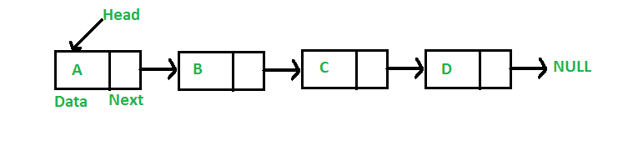

[**Queue**](http://en.wikipedia.org/wiki/Queue_%28data_structure%29)**is a linear structure which follows a particular order in which the operations are performed. The order is First In First Out (FIFO).  A good example of queue is any queue of consumers for a resource where the consumer that came first is served first..**

* **typedef** **interpretation is performed by the compiler whereas #definestatements are processed by the pre-processor.**
* **Linked list is used to store the data of the applicant and each applicant form is linked to the next form in terms of status being ready and application numbers.**

**Queues is implemented for storing multiple applications in a systematic manner.**

**We have used various functions to perform different actions on the linked list.**

**Like void init() is used to initialize the queue pointers, getDetails() is used to accept applicant details, addApplication() is used to add the applicant forms to the queue.**

**EXPECTED OUTPUT:**

**Once the user has entered all details, upon selecting to check the status of the form, the first application form status displays ready. The user details are displayed if one selects the print form option.**

**Printout of the program is as follows:**